Just a few interesting excerpts from the following news report:

"Feathered" Dinosaur Was Bald, Not Bird Ancestor, Controversial Study Says
http://news.nationalgeographic.com/news/2007/06/070601-dino-feathers.html

Stefan Lovgren
for National Geographic News
June 1, 2007

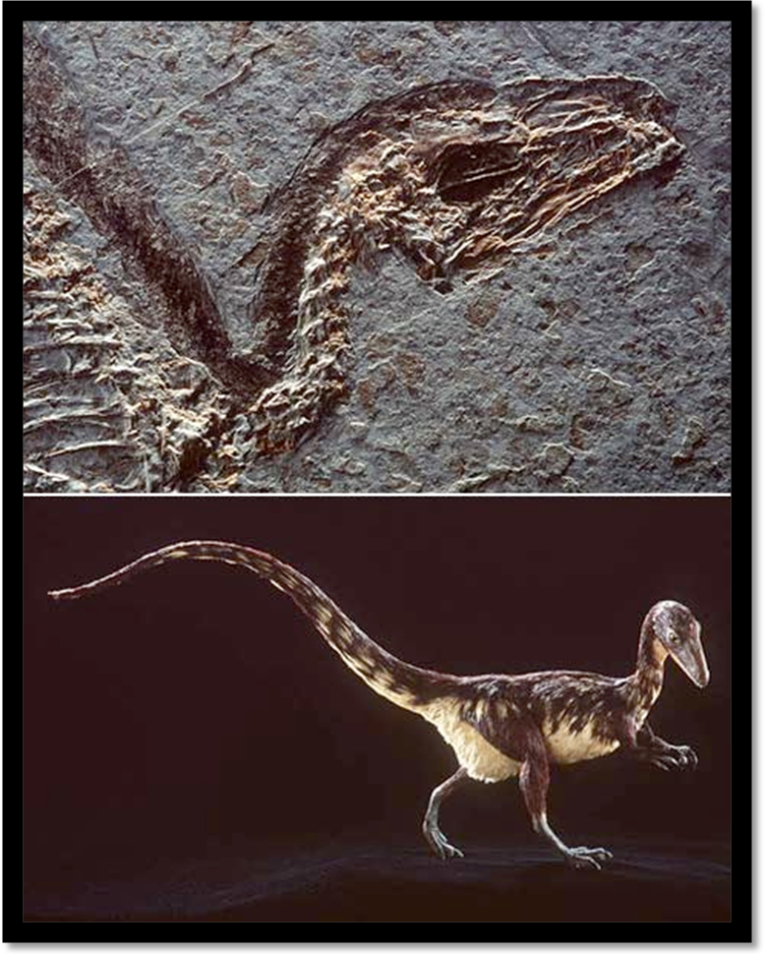

A shadow of doubt has been thrown over the widely held theory that dinosaurs had feathers and that they gave rise to modern birds. In a new study, researchers examined the fossil of a 140-million-year-old turkey-size dinosaur called Sinosauropteryx. Other experts had previously concluded that distinctive patterns found on the skin of a Sinosauropteryx fossil were remnants of downy protofeathers, making the species the most primitive feathered dinosaur. But the new team says that their analysis shows that the creature was actually bald.
The patterns are the remains of "structural fibers, probably collagen—the most abundant fiber in vertebrates—of the skin and the dorsal frill," said lead study author Theagarten Lingham-Soliar of the University of KwaZulu-Natal in South Africa.
The findings were published last week in the journal Proceedings of the Royal Society B.
Lingham-Soliar and colleagues' results support the arguments of a small but highly vocal group of scientists who say there's no evidence of dinosaurs ever having feathers.
"The existence of protofeathers in these dinosaurs was considered critical evidence that birds were derived from dinosaurs," said study co-author Alan Feduccia, a bird evolution expert at the University of North Carolina at Chapel Hill. "What we have shown is that there's absolutely no evidence whatsoever that protofeathers existed in dinosaurs, period."
But the majority of scientists in the field are unconvinced.

"These people have been flogging the same horse for a long time," said Kevin Padian, curator of the University of California Museum of Paleontology. "It is appalling that Proceedings B chose to publish this nonsense."
Current theory says that over time theropods developed plant-eating habits, grew feathers to keep warm, and took to the trees for safety. But skeptics of this theory argue that birds evolved earlier from a common ancestor with dinosaurs, and that dinos never had feathers. For the new study, researchers looked at a recently discovered Sinosauropteryx specimen also found in Liaoning.
"The peripheral dorsal structures are the remains of fiber reinforcement of the frill" that extended from the head to the tip of the tail of the dinosaur, said lead author Lingham-Soliar. "Their regular nature and straightness defies the notion of them being soft pliable structures [like feathers] but rather high-tensile fibers such as collagen."
The fibers show a striking similarity to the collagen found on the skin of sharks and reptiles today, the authors say. And without protofeathers in Sinosauropteryx, the authors argue, the theory that feathers first evolved in dinosaurs—not for flight but for insulation—falls flat.
David Unwin, a vertebrate paleontologist at the University of Leicester in England, considers himself neutral on the issue. He said that scientists need to better understand how soft tissues in well-preserved dinosaurs are actually fossilized. But the new study falls short because it relies only on microscopic analysis, with no additional CAT scans or chemical tests, he said. "They merely looked at the tissues and said, Oh, they're straight and well organized … it must be collagen," Unwin said. In some cases, he said, the fibers do look like collagen. "But what they didn't draw attention to is that there are other tissues in there that don't look like collagen and might be protofeathers."
And what about the many other dinosaurs that appear to have been feathered? Feduccia, the study co-author, says these creatures are actually descendants of birds that lost their ability to fly. "When they become flightless, they superficially resemble small dinosaurs," he said.

Minority View
Storrs Olson, the curator of birds at the Smithsonian Institution's National Museum of Natural History, has been a vocal critic of the theory that modern birds evolved from dinosaurs. "The whole notion of feathered dinosaurs is a myth that has been created by ideologues bent on perpetuating the birds-are-dinosaurs theory in the face of all contrary evidence," he said.
National Geographic magazine and other media have heavily publicized stories about feathered dinosaurs. But contrarian views struggle to get heard, Feduccia said.
"One of the primary arguments used to deflect our view is that we are a fringe group," he said. "But if science operates by a majority view, we're in serious trouble. "We are dealing here basically with a faith-based science where the contrarian view is silenced to a large extent by the popular press," he added.
The University of Leicester's Unwin said that science benefits from opposing views, "because it keeps the people who are arguing for a dinosaur origin for birds on their toes."
"One way the [latest] paper may be significant, though, is that it suggests that the story of the origin of feathers may not be quite as simple as we would like to have it."

The following is an E-mail exchange between myself and Zachary Armstrong. Zach starts off (bold font):

Dear Mr. Pitman,
Hi, my name is Zach, and I find your website very interesting and helpful,
but I do have some problems with your article on dinosaur feathers. I do not
think that the feather impressions on the dinosaurs are collagen fibers for
several reasons.
First, when the Confuciusornis specimens were found in the Liaoning deposits
in China, and had beautifully preserved integument, nobody claimed that these
were collagen fibers. Nor did researchers claim when they found similar
mammal remains with fur around their bodies that it was collagen fibers. I
think that was inconvenient for some creationists that dinosaurs had
feathers, or feather-like integument. But I do not believe, that feathers or
"protofeathers" on dinosaurs provide evidence for evolution in the way that
many have thought. For example, fur on bats does not alone provide evidence
that they evolved from rats, or whatever group they are claimed to have
evolved from.
Second, I believe that all the reasonable skeletal evidence in "Dinosaurs of
the Air" (by Greg Paul) gives strong proof of the relationship between
dinosaurs and birds. This does NOT mean, however, that I think that birds
evolved from dinosaurs. It just proves that they are from the same basic
group of animals.
Third, I believe that this evidence supports a possibly new view that I have
of the creation account in Genesis. (I believe firmly the scripture at 2
Timothy 3:16,17, "All Scripture is inspired of God and beneficial for
teaching, for reproving, for setting things straight, for disciplining in
righteousness, that the man of God may be fully competent, completely
equipped for every good work.") The account where God puts Adam to sleep and
builds Eve from a rib at Genesis 2:21,22 may in fact give us a glimpse of how
God created all living organisms. He may have similarly taken "parts" of
other animals and built upon them to create new animals (such as birds from
theropod dinosaurs, etc.) Thus I do not think that the reasonably derived
conclusion from the physical evidence in fossils that dinosaurs may have been
feathered is a problem.
I have also attached an essay that I wrote about a month ago that deals with
evolution to a degree and another essay that deals with it more in full that
I wrote earlier (over a year ago).
If you would comment on these and the above comments in my email and reply,
it would be much appreciated.
Sincerely,
Zach Armstrong

Hey Zach,

Thanks for your letter. You must understand though, it isn't that I have a problem with there being feathered dinosaurs. I don't in principle. God could have designed life whatever way he wanted. After all, a platypus has fur, a bill, lays eggs, and has a poison spur. So, you see, I don't have a theoretical problem with there being feathered dinos. It is just that the evidence used to support this idea is very weak at best.

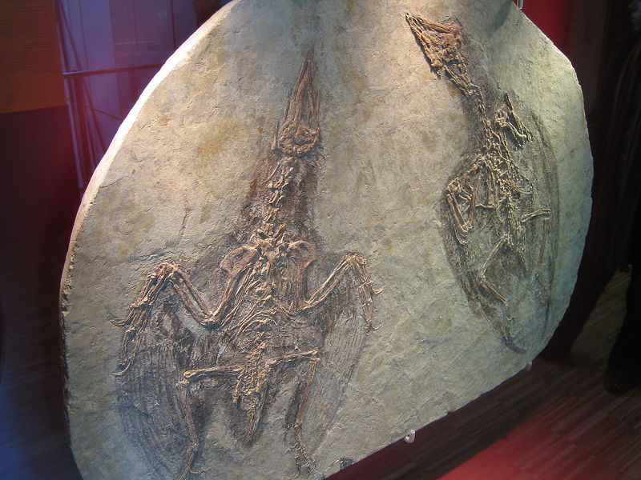
You mention Confuciusornis. That's a real fossil bird with fully developed feathers. That's why nobody said that these feathers were just collagen fibers (see image above). This is a far cry from what are being hailed by many mainstream scientists as "protofeathers" on reptilian dinosaurs.

Real feathers are actually very complicated structures. Evolving them would be quite some trick indeed. One might even say "miraculous". The same thing goes from several other uniquely complex systems that exist in birds, but not reptiles. In particular, the respiratory system of birds is quite extraordinary and uniquely different from the reptilian system. And, although the basic skeletal system needed for flight of many different kinds of creatures share certain similarities, there are also distinct differences as well. In any case, the respiratory system difference is an interesting read if you get the chance to look into it a bit.

Beyond all of this, the article listed on my website questioning the "feathers" of reptilian dinosaurs is not just my idea, it is taken exclusively from a sizable minority of mainstream scientists who are starting to question this notion. I mean really, Storrs Olson isn't just any joe-blow. He is the curator of birds at the Smithsonian Institution's National Museum of Natural History. Even so, he has been a vocal critic of the theory that modern birds evolved from dinosaurs. "The whole notion of feathered dinosaurs is a myth that has been created by ideologues bent on perpetuating the birds-are-dinosaurs theory in the face of all contrary evidence," he said.

I tend to agree. The best evidence available suggests that birds in the fossil record are just that, birds, and that dinosaurs in the fossil record are also just dinosaurs. There is no really convincing evidence of some clear intermediate between reptiles and birds.

Anyway, I do thank you for your thoughts. I haven't had a chance yet to read through your essays, but I'll get back to you when I do.

Thanks again . . .

Sean

Hey Sean,
I was not claiming that birds evolved from dinosaurs. What I was saying is
that they probably are from the same basic group of animals (i.e., birds
(Aves) are to the superoder Dinosauria what bats (Chiropterans) are to the
superoder Archonta or to the cohort Ferungulata). I do agree with you that
dinosaurs are dinosaurs, and birds are birds and there are enough
morphological differences to separate the two groups. However, their
morphological similarities outweigh the differences.
For instance, both the forearms of dinosaurs and birds have a lunate carpal.
Dromeosaurs such as Deinonychus and others have a very birdlike breastplate,
some even have a keeled sternum, just as birds. Also, many of the small
theropodian dinosaurs of the Maniraptora have a hyperextendable second toe,
like the cassowary and some other extinct birds. Also, the dromeosaurs have
retroverted pelves like birds. Some dinosaurs, such as Nomingia had a
pygostyle-like mass of vertebrae at the end of its tail. Also, all dinosaurs
had an extensive air-sac system that rivaled birds; even the long-necked
sauropods had air sacs to lighten their skeletons. Many of the small
maniraptorans also had honey-comb structured bones. So I think the air-sac
argument against dinosaurs is also rendered moot.
Not one of these animals mentioned above are particularly closely related to
basal birds, yet had many similar features as birds. Anti-dinosaur theorists
often use "parallel" evolution to sweep this evidence under the rug, claiming
it is convergence. Since both you and I do not believe macroevolution is
responsible for the diversity of life on earth, this point of "convergence"
is moot. It is interesting that many anti-dinosaur theorists use Alan
Feduccia, Storrs Olson, and L. Martin to refute the dino-bird connection.
However all of these are evolutionist who favor more basal archosauriforms as
evolutionary ancestors.
Obviously, anti-dinosaur theorists do not claim these origins, they simply
say that just as these scientists do not put much stock in the dino-bird
connection, as it were, that a similar non-evolutionary argument can be made.
I understand this, but I think a more likely explanation can still be
asserted, from a non evolutionary standpoint, that dinosaurs and bird are
related based on the morphological and integumentary evidence.
Furthermore, unambiguous evidence is found of feathers on dinosaurs on
Caudipteryx (where contour feathers are found) and on a juvenile
sinornithosaur skeleton where the feathers are so long that a
"collagen-fiber" argument is unreasonable. Caudipteryx is an oviraptor-type
dinosaur based on the unusual fusion of the upper palate in its skull and by
its pelvis (among other morphological evidence). The Sinornithosaur is
obviously a dinosaur based on its skull, rod-strengthened tail, and over-all
similarities to other maniraptorans.
What about in Sinosauropteryx, from which your argument (and other's) is
based? Well, first of all look at this image:
http://en.wikipedia.org/wiki/Image:Fossil_of_Sinosauropteryx.jpg
You can clearly see there are impressions, not just dorsally, but also under
the tail and the thorax region. This clearly is not from some dorsal frill or
what-have-you. They stick out much to far to be collagen fibers, etc. I will
admit however that the specimen's impressions however are too unclear to show
whether they are "true" feathers or more kiwi-like furry feathers. This will
be up to some debate for a long time, but even if we state that the evidence
is too ambiguous, Dilong paradoxus shows us conclusively that non-bird
theropdian dinosaurs had feathers. (Also, if it is collagen fibers, why are
they not preserved around the feet and legs in these specimens? That's
something to wonder about.)
Go here to see pics:
http://www.amnh.org/science/papers/feathered_tyrannosaur.php
If you scroll down the third picture clearly shows distal tail vertebrae that
have long filamentous fibers that are undoubtedly ratite-like feathers, too
long to be collagen fibers. Additionally, collagen has great tensile
strength, and is the main component of fascia, cartilage, ligaments, tendons,
bone and teeth (why is collagen strongly preserved around the dorsal
vertebrae and caudal vertebrae when it should be found most densely packed by
the strong tendons in the foot and arms (it would not be sticking out by the
way like feathers? It should lie more closely and flatly on the specimen's
bones)
Furthermore the the fossil feathers of Shuvuuia deserti, have even tested
positive for beta keratin, the main protein in bird feathers, in
immunological tests (from Wikipedia). I believe this is conclusive (to the
degree possible) that dinosaurs had feathers.
Finally, the icing of the cake is put on when I read this article, and
especially the comments ( the first and second comments especially)that imply
that both Feduccia and L. Martin have to some degree sided with the dino-bird
theorists:
http://ngm.typepad.com/stones_bones_things/2007/09/feathers-for-ve.html
Best regards (and thanks for listening to my tangential rants),
Zach A.
P.S.: It is interesting to note that the relationships of the Chiropterans
(bats) are unclear too.

Hey Zach,

Thanks again for your thoughts on this issue. Most interesting. I will have to look into a few of your points further.

Until then, it seems like some of your arguments are quite debatable, even in the mainstream community.Take your argument that Caudipteryx is a clear example of a dinosaur with unambiguous feathers. While no one argues that this creature was indeed feathered, the idea that it was a clear dinosaur is debatable.

Others, such as Stephen Czerkas and Larry Martin have concluded that Caudipteryx is not a theropod dinosaur at all. They believe that Caudipteryx, like all maniraptorans, is a flightless bird, and that birds evolved from non–dinosaurian archosaurs. Also, while there are those who disagree, Halszka Osmolska et al. (2004) ran a cladistic analysis that came to the conclusion that Caudipteryx was a bird, not a dinosaur. They found that the most birdlike features of oviraptorids actually place the whole clade within Aves itself, meaning that Caudipteryx is both an oviraptorid and a bird. In their analysis, birds evolved from more primitive theropods, and one lineage of birds became flightless, re-evolved some primitive features, and gave rise to the oviraptorids. This analyis was persuasive enough to be included in paleontological textbooks like Benton's Vertebrate Paleontology (2005). (Link)

So, at the very least, it doesn't seem to me that Caudipteryx as an non-debatable example of the close relationship of birds and dinos - even from a mainstream perspective.

As far as dino air sacs, that's a very interesting argument. It seems like some real dinosaurs did have very avial-like air sacs in similar locations. However, establishing that dinosaurs had a bird-like air sac system leads to yet another question: did these pneumatized dinosaurs breathe like birds — did they use their air sacs to pump air through their lungs in a continuous flow? If saurischian dinosaurs did have this sort of "hot-rod" respiratory system, it could overturn current views of how active dinosaurs were. But answering that question will require more work, suggests Matt. (Link) In other words, this very important aspect of respiration isn't answered yet. Interesting argument though.
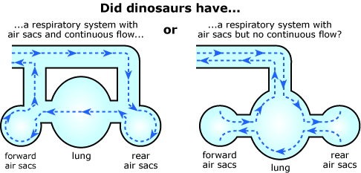

As far as Sinosauropteryx goes:

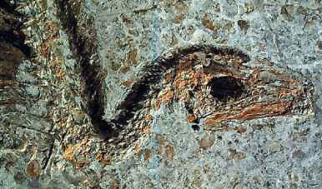

I'm not so sure that these features are "far too long to be collagen fibers". It seems at least plausible to me that the reason why these fibers were not preserved around the feet and hands is because they were likely structural to projections like dorsal frills and other supported skin assemblages. The same thing goes for the Dilong fossil "proto-feathers".
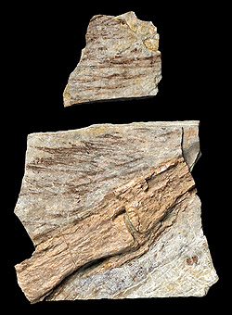

As far as the β-keratin argument goes, β-keratin is generally found in reptilian skin (in the stratum corneum to supply both rigidity and water-proofing) as well as the claws, beaks, and feathers of birds. I really don't see how this is some sort of distinguishing feature - to distinguish between a collagen-based frill and feather-like structures.

As far as the retroverted pelvis of dromaeosaurs, some researchers, like Larry Martin and Stephen Czerkas, believe that dromaeosaurs, along with all maniraptorans (as discussed above) are not dinosaurs at all. (Link) So, this argument really isn't what I would call conclusive either.

Interesting thoughts in any case - especially for a tangent issue ; )

Thanks again . . .

Sean

Hey Sean,
Thanks for your insights. However (uh-oh, here I go again), collagen fibers
do not have beta-keratin protein. If they were scales, yes they would have
beta-keratin protein. However, they were obviously not scales.
Interestingly, some of the Sinosauropteryx specimens have scales preserved
around their feet. This means two things, (1) the dorsal frill, had it been
scaled would have preserved the scales NOT the collagen fibers, (2) collagen
fibers are microscopic and are not fossilized in the way the integument is
seen.
The only pictures I have seen of fossilized collagen fibers are seen only
through electron microscopy, a far cry from the dark preservations on
Sinosauropteryx. Sinocalliopteryx and Dilong also have these preservations
although much lighter in color, yet still are to large and obvious to be
collagen fibers. Also, although I have not seen the actual material in
photos, Dilong is supposed to have a fairly large fan of feather-like
integument at the tip of its tail. This indefatigably provides evidence of a
non-bird, theropodian dinosaur with feathers.
Your argument, from Czerkas et. al, that maniraptorans are birds I have heard
before, even from hardcore dino-bird scientists such as Greg Paul (I strongly
recommend reading his book "Dinosaurs of Air" at any rate, because in order
to refute an argument you, as I'm sure well aware with the evolution debate
in general, must understand it). I think it muddies the waters ("what is a
bird? what is a dinosaur?" and the like). I think since the Caudipteryx
wikipedia article shows that an even amount of cladistic analysis's have
either supported or refuted the "its a dinosaur/bird)" argument, its not an
"either or" situation. Generally, the case is in science when you
consistently get "contradictory" results, they are not contradictory but
rather complementary (see my article on Philosophy, God, and Truth that I
sent you previously for further details--about a priori v. a posteriori
arguments)or we're asking the wrong question (or sometimes both). As Greg
Paul so eloquently stated in "Dinosaurs of the Air", p. 272:
"We have previously discussed how, in this view, if some feathered dinosaurs
were in Aves, then they were birds, not dinosaurs. In other words, some or
all avepectoran "dinosaurs" are not really dinosaurs. Instead they form an
arboreal avian clade with birds that parallels the true, terrestrial theropod
dinosaur clade. This arrangement may appeal to those who have opposed the
dinosaur-bird connection but find it increasingly difficult to deny that the
most birdlike dinosaurs are very close to birds, especially as feathered
"dinosaurs" continue to appear. This kind of thought process is already
happening in a certain sense with Protarchaeoppteryx and Caudipteryx, which
are being called secondarily flightless birds despite the strongly
dinosaurian nature of their skeletons.
"This way lies phylogenetic madness. The problems and issues that surround
the naming of various groups and grades cannot be allowed to influence the
restoration of taxonomic categories. First, we must gather and analyze the
data contained within various groups considered WITHOUT BEING BIASED BY
PRECONCEPTIONS OF TRADITIONAL VIEWS OF WHAT IS WHAT. Only after the data
analysis is complete can the problem of what to call certain birdlike
dinosaurs be considered. If we agree that Archaeopteryx is a basal member of
Aves and that certain dinosaurs areeven closer to modern birds than
Archaeopteryx, then the dinosaurs are in Aves and then are birds in a broad
sense. But, because nothing in the skeletons of these dinosaurs separates
them from dinosaurs proper, and because their anatomical grade remains more
dinosaurian than avian, they are still dinosaurs as well as birds. We find
ourselves in the messy, murky gray zone between major groups; what we need is
a simple, informal term that combines the aspects of both types. That term is
"dino-bird"."
(The caps letters in the quote are not my emphasis, they are Paul's, although
he italicizes it, but I cannot use italics in my email system)
Thus, my main argument from this is that all birds are dinosaurs, but not all
dinosaurs are birds (i.e., all squares are rectangles, but not all rectangles
are squares). This is a similar situations as the Chiropterans (bats) and
mammals (which I will not go in to, the situation is far more complicated
than this (oy!), just know that David Peters has noted that there are at the
very least four different groups that bats may be related to, yet the
evidence is so far inconclusive, that does not mean, however, that we should
make the Chiroptera its own class). This really has nothing to do in itself
with evolution, just classification, but many people who defend creation
often feel that this issue must be attacked because it deals with evolution,
although I think there is a happy middle-ground which far to few people take,
namely birds are to dinosaurs what bats are to the Archontans or
Ferungulatans.
Also, I should remind you that the beta-keratin analysis were based, not on
Sinosauropteryx, but on Shuvuuvia, which does not have a "frill" and is in
fact much more birdlike skeletally than Sinosauropteryx, and has been
considered in some analysis's to be a basal bird, yet it has the filaments
that are almost a carbon-copy of Sinosauropteryx found on it. Interesting...I
don't think basal birds have scales or beta-keratin based "frills". Another
nail in the coffin for the non-dinosaur argument.
I think this example at any rate is a great metaphor for the
evolution-creation debate. The scientist say there must be an answer, yet the
answer must be evolutionary, materialistic, non-intelligent. This is an a
priori argument which scientist are supposed to reject, as you have so
correctly pointed out on your website, yet for some reason when it comes to
evolution, they sweep this point under the rug.
Also, interestingly, both the evolution-creation debate and the dinosaur-bird
debate have several things in common. One, there is a variety of competing
explanations that differ slightly (and all are reasonably on-the-level with
each other). Two, both usually take an "all or none" attitude. And three, the
closer we look the more the issue is muddied. A good rule of thumb when this
happens is that we either are not being open-minded enough, or we have
started out with a wrong assumption(s). This is partly why I find this so
fascinating.
But as one of the essays that I sent you shows, there must be an explanation.
So we drum our fingers as we wait for more evidence to come in (as one
blogger, Zach Miller, often states, "We need more fossils!"). although I'm
fairly confident that birds are dinosaurs.
------------------------------------------------------------------------
On another note, I have some questions on the "non-randomness" of evolution.
I know that Richard Dawkins's main argument in "The God Delusion" is that
evolution is nonrandom, it chooses between "bad and good" genes or memes
(that is oversimplifying it, I know, but bear with me). I also know that you
have stated that evolution cannot bridge the gap of neutral functions, and
that this is the major hole in his argument. What are some examples of
"neutral gaps?" Also, does Dawkins explain his comment on "purpose directed
physics", even though he claims purpose is illusory? That seems
contradictory.
On the nonrandomness issue I would like to note that even if there are
certain "good or bad" functions, they are not necessarily equal in number,
thus finding "good" functions might still be, in essence, random. (In fact
his whole argument about religion and morals being "good mutations gone bad"
seems to argue against evolution being nonrandom, or as elegantly simple as
Dawkins would hope or imply.)
Also, in the new issue of "Discover" magazine a very interesting theory about
the origin of life in ice and I was wondering if you have read it and if so
what are your thoughts on it?
"Over and out"
Best regards (and again, hats off to you if you made it this far through my
tangential rant(s) (without skimming, that is)),
Zach A.

Hey Zach,

Thanks again for your thoughts on this issue.

The beta-keratin (without alpha-keratin) was found in Shuvuuia deserti. At least some are arguing that Shuvuuia deserti "belongs to a group of primitive, flightless birds." (Link) As with Caudipteryx, Shuvia deserti is classified as a maniraptor. As noted in my last reply and as you note in your most recent reply, maniraptorians are considered by some scientists to be birds, not reptiles or dinosaurs. As you yourself have noted, Stephen Czerkas and Larry Martin have concluded that Caudipteryx (and Shuvuuia deserti as well as all maniraptors) is not a theropod dinosaur at all. They believe that Caudipteryx, like all maniraptorans, is a flightless bird, and that birds evolved from non–dinosaurian archosaurs.

So, it seems as though the beta-keratin argument is at best debatable - does it not?

Now, I understand that this entire discussion is tied up with the definitions of "birds", "reptiles", and "dinosaurs". The same problems are present with the discussion of humans and apes and the like. Certainly there are similarities. There are also interesting differences. Where is the dividing line? The same problems come when one is talking about "species". These terms are often very subjective. That's really my main point here. Scientists have a habit of making conclusive declarations based on morphology that may in fact be way off base when it comes to genetics and functional systems that are unique between two different "species" or "kinds". Also, what sometimes seems to be unique isn't always unique. Often different creatures have been given different species and even genus and higher level classifications until it was found later that they were simply morphological or sexual variations of the same breeding pool.

This is one of the big problems with the theory of evolution. To much weight it put on fossils and morphological features in my view. Such interpretations are often not significantly more reliable than fairy tales told to children. I mean, you may be right with the feathered dinosaur idea. It isn't an unreasonable notion. It is just hard to really use as an evolutionary argument is all because of the problem of determining what is and is not a true evolutionary "intermediate" or "missing link". Again, conclusions based on morphology and even on genetics are often very misleading . . . and, obviously, quite debatable.

_________

Toward the end of your last response, you ask about examples of non-beneficial gaps. The size of the smallest non-beneficial gap between what exists and what might exist to some benefit grows in a linear manner with each increase in the minimum structural threshold requirements for potentially beneficial systems under consideration. I call these various minimum requirements "levels of functional complexity". Higher level systems are separated from each other in sequence/structure space by a larger average gap size that is linearly greater in size than lower-level systems. Consider also that the minimum gap size is always smaller than the minimum structural threshold size requirement.

For example, consider functional level that requires a minimum of 100 fairly specified amino acid residues producing a ratio of potentially beneficial vs. non-beneficial of 1e-40. This size and specificity requirement or "level" translates into an average gap size of around 30 residue differences between potential targets. Depending on the size of the population that is searching for new targets via random walk/selection, the minimum gap size between what the population already has and the next closest potential target to at least one member of that population is always smaller than the average gap size - along a Poisson distribution. A very large population of, say, 1e30, may have a likely minimum gap size of only one or two residues changes. That is why evolution at such a low level is fairly commonly observed in real life. However, when it comes to higher-level systems, evolution is much less common - exponentially so. In fact, evolution has not been observed beyond the 1000aa threshold level (given the same degree of specificity).

There isn't a single example in literature of evolution, in action, at or beyond this level - not one. Yet, every living thing has many systems that go far beyond this level. Such systems, in my view, clearly require an intelligent origin and deliberate creative power.

I go into this concept in more detail in several essays on my website (Kenneth Miller, Steppingstone Problem, and Flagellar Evolution).

Hope this helps and thanks again for your thoughts.

Sean

Hey Sean,
I do understand what you are saying now. For instance Steve N.G. Howell said
(even though he was talking about two species of gulls),"We can't learn how
much they interbreed until we can distinguish them, but we can't distinguish
them because they appear to interbreed." Thus your problem is with the
reliability of taxonomy and genetic based separations. I wholeheartedly
agree.
I think you may have missed my point on Shuvuuia, though. My point was taht
since it had filaments like Sinosauropteryx (which is clearly a dinosaur) and
Shuvuuia is considered by many to be a flightless bird, how come they have
the same hairlike/feather-like integument ? Since the only integument that
covers birds (besides their feet and bills) is feathers, we must conclude
that since they have the same hairlike integument, it must be hairlike
feathers that adorn both birds and some theropodian dinosaurs, thus cementing
at least this part of the dino-bird link: some dinosaurs must have had
feathers of some sort (that is because Shuuvuia must be a bird if we take
Caudipteryx to be a bird because the pelvis of Shuuvuia is far more birdlike
than that of Caudipterx; so is its skull and other features.
---------------
I have question concerning the neutral gaps. I was actually asking for a real
life example of a gene mutation that is neither "good" nor "bad", that thus
cannot be dealt with by natural selection (not the theoretical gaps that
increase exponentially, although they must exist, I am inquring of a real
life example).
Also what does "1000aa" mean? Could you explain these "functional gaps of
complexity" more, that is, dumb it down a little (I have less experience with
molecular chemistry jargon and the like--confusion on my end can be avoided
by clear, concise, yet specific definitions if you could provide them)?
Thanks for the information and communication--it is much appreciated,
Zach A.

Hey Zach,

I'm not convinced that Shuvuuia has filaments that are clearly the same as Sinosauropteryx. The filaments of Shuvuuia are described as "long" and, in particular, "tubular" in structure (Link). It seems to me that the filaments of Sinosauropteryx are neither long nor obviously tubular in nature. Now, the word "long" is admittedly subjective. However, the term "tubular" is not. A tubular filament is quite a bit more complex and "feather-like" than a simple non-tubular filament - especially given the additional immunologic evidence. In short, establishing a clear morphologic connection between Shuvuuia and Sinosauropteryx on their filaments is a bit strained at this point - in my opinion.

So, again, we are back to the weakness of establishing relationships, evolutionary or otherwise, based on morphology alone.

___________

As far as neutral gaps, the majority of mutations that occur in each generation are functionally neutral - or at least very close to it. There is even a "Neutral Theory of Evolution" which was proposed a while back by Motoo Kimura (Link). For example, on average, every human being suffers between 200 to 300 mutations from one generation to the next. Of these, less than 10 (some suggest as few as 2 or 3) are functionally detrimental and only a tiny fraction of these are "beneficial" (ratio of 1000 detrimental vs. 1 beneficial). (Link)

So, there you have your real life example of neutral mutations.

Of course, the non-beneficial gaps are measured from what already exists as staring points within a gene pool to potentially beneficial targets that only exist within the potential of sequence space. Non-beneficial gaps take in both potentially neutral as was a detrimental mutational changes.

As far as the term "1000aa" it means 1000 amino acid residues. Amino acids are the building blocks of proteins. There are 20 different amino acids - similar to the 26 letters in the English alphabet. These "characters" are used to build protein sequences similar to the building of English words, phrases, and sentences. Most molecular machines, of course, are built of these amino acid characters and are therefore protein-based. The more complex the minimum structural requirements of the molecular machine, the greater the gap that will exist between it and the next closest potentially beneficial machine at the same level or one level up or one level down.

For example, what is the ratio of meaningful vs. meaningless 2-character sequences in the English language system? About 1 in 7. 3-character sequences? About 1 in 18. 7-character sequences? About 1 in 250,000 . . . etc.

This same pattern is seen in protein-based systems. Higher-level systems are exponentially more rare in sequence/structure space relative to all the junk that surrounds them and makes them like island oases in a vast desert. Getting from one island to the next via any form of random walk or step of any kind gets exponentially more difficult with a linear increase in the distance between the starting point(s) and the next closest potentially beneficial island oasis.

Make sense?

Anyway, hope this helps - - and thanks again for your thoughts.

Sean

Hey Sean,
> I'm not convinced that *Shuvuuia* has filaments that are clearly the same as
> *Sinosauropteryx*. The filaments of *Shuvuuia* are described as "long" and,
> in particular, "tubular" in structure.
> It seems to me that the filaments of *Sinosauropteryx* are neither long nor
> obviously tubular in nature. Now, the word "long" is admittedly
> subjective. However, the term "tubular" is not. A tubular filament is
Note though that the rest of the skeleton is more or less flatly compressed
in Sinosauropteryx, even though we may assume that the bones were "tubular"
or types of cylinders, not flat; because the bones are flat (more or less) we
cannot assume that they are not bones. It is because of the particular
environment that Sinosauropteryx was fossilized in, which was different than
the one Shuvuuia was (and, correct me if I'm wrong, but I believe the
Shuvuuia skeleton was not compressed even nearly to the degree that
Sinosauropteryx was--the skull looks fairly 3-dimensional, for instance,
compared to Sinosauropteryx's).
> quite a bit more complex and "feather-like" than a simple
> non-tubular filament - especially given the additional immunologic
> evidence. In short, establishing a clear morphologic connection between *
> Shuvuuia* and *Sinosauropteryx* on their filaments is a bit strained at this
> point - in my opinion.
>
> So, again, we are back to the weakness of establishing relationships,
> evolutionary or otherwise, based on morphology alone.
Agreed. Yet to what point should we take this skepticism? Be it agreed that
we do need to be shrewd and not gullibly believe everything, although I also
think that there is a point when it tends toward ridiculousness skepticism,
if you see what I mean. For instance the close morphological similarities of
bats to other mammals in most ways besides their wings leads many to the
reasonable conclusion that they are mammals. Other morphological
characteristics such as hair, mammary glands, etc., lead us to the assumption
they are some type of mammal. The same thing, I believe goes for birds as
dinosaurs.
You do make a good point however on determining relationships based on
morphology. For instance I believe some of our (human) various organs have
been compared to pigs and other animals in certain respects. Also, think of
the platypus with its crazy mixture of features.
So one must decide: either the relationships and groupings we see are
unnatural or natural. If you are Christian, or base your beliefs of the
Bible, the Bible comments to a degree on these relationships. It talks of
flying creatures, creeping things, wild beasts of the field, domestic
animals, sea creatures (also translated, "great sea monsters" or "great
reptiles"), etc., Now the flying creatures no doubt include flying and
flightless bird, as well as insects that fly; the "creeping things" are
probably small reptiles, amphibians, mammals, and flightless arthropods
(insects, spiders, etc.); the wild beasts might be large mammals, reptiles
and large flightless birds (such as the ostrich); and the sea creatures or
great reptiles might include both fish, large and small, as well as marine
mammals and large reptiles (such as turtles, some crocodiles, and other
extinct reptile-like creatures) as well as the extinct dinosaurs and other
contemporaries. The Bible obviously is not commenting on "true" relationships
(I'm not even sure now what those are)but relationships of habitats and the
gross morphology. So both evidence is inconclusive and I agree with you that
morphology may not be the best way of such research. }--(my comments, more
below)
__________
Does this mean that these gaps cannot be crossed even by simple mutations
accumulating on one of the lower levels of mutations (as Dawkins implies)? If
they cannot this really nails the coffin on the theory of evolution!
Best regards, thanks for your comments, and reading mine,
Zach A.

Hey Zach,

I wasn't referring to the tubular bones, but to the tubular filaments of Shuvuuia.

My point on morphologic relationships is that it is often very difficult to determine ancestral relationships based only on morphology - despite many similarities.

There is no argument that birds and reptiles share many interesting morphologic and even genetic features. So do humans and apes. In fact, all living things are very similar in many ways - not the least of which is the basic genetic code that is common to almost all life on this planet.

My point then is not so much to question similarities, but to show that scientists are often guided more by their pre-conceived notions in their interpretations of these similarities than by true science that is built upon predictive value of hypotheses with the potential for falsification. There is simply a great deal of bias in science - as there is in all human endeavors. That is why a bit of personal investigation and consideration of the evidence is needed before this or that "story" is accepted as "truth".

__________

The non-beneficial gaps refer do not refer to the types of mutations, but to the number of character changes needed at minimum before the next closest potentially beneficial sequence in sequence space could be realized. Because lower-level functions are closely packed together in sequence space, relatively speaking, the gaps between these "islands" are relatively small. For very low-level functions (i.e., less than 100aa in size) the minimum gap sizes are often less than a handful of character changes. Such small gaps can indeed be crossed by random mutations adding up over time - and in very short order for a large colony of individuals. There are many examples of low-level evolution. Some of them are quite famous - like antibiotic resistance. However, all such examples of evolution in action in literature are low-level examples. Evolution starts to stall out, in an exponential manner, with each step up the ladder of functional complexity until it completely stalls out well shy of the 1000aa threshold.

For more information on this topic, I've written several essays that are listed on my website.

Hope this helps.

Sean

Hey Sean,
Everything you have said so far has been beneficial, especially the topic of
evolutionary neutral gaps, evolution stalling out, etc. But before I comment
further on that (possibly in a later email) I have to address the feathered
dinosaur topic, again. I will be commenting on some of your previous
comments.
You wrote: "I'm wasn't referring to the tubular bones, but to the tubular
*filaments* of *Shuvuuia*. My point on morphologic relationships is that it
is often very difficult to determine ancestral relationships based only on
morphology - despite many similarities."
Me: Of course not; I looked back at what I emailed to you and realized my
point did not follow, so here's a (hopefully) better expalnation: My analogy
was that as the bones of Sinosauropterx were crushed, so were the structures
surrounding, enough so that had they been tubular, that evidence would have
been erased, thus your point that Sinosauropteryx's integument is clearly
different than Shuvuuia's is rendered inconclusive.
You wrote: "There is no argument that birds and reptiles share many
interesting morphologic and even genetic features. So do humans and apes.
In fact, all living things are very similar in many ways - not the least of
which is the basic genetic code that is common to almost all life on this
planet."
Me: True, and yet morphology and genetics TOGETHER can and do lead to fairly
sound SCIENTIFIC CONCLUSIONS in the end. An example: Accipitrid Vultures vs.
Carthartid. They were once thought related based on their overall gross
"vulture" features, namely, scavenging and a more-or-less bald head. Now
review of the MORPHOLOGICAL and GENETIC evidence indicates that the
carthartids are related to storks & their allies, while the accipitrid
vultures are still more closely related to other accipitriines (hawks,
eagles, etc)(see www.skullsite.com and type in "vulture", see attachment for
a pdf of the carthartids). Thus a fairly sound conclusion has been reached
about vultures, although admittedly the Wikipedia articles show there is
still some squabbling over the details. I think thus a similar conclusion has
been reached about dinosaurs and birds.
In fact, the tyrannosaur specimen found by Mary Higby Schweitzer that
preserved soft tissue and protein has been tested and the results show that
tyrannosaurus was, in subsequent studies, reported in the journal Science in
April 2007, by Asara and colleagues concluded that seven traces of collagen
proteins detected in purified T. rex bone most closely match those reported
in chickens, followed by frogs and newts. This shows again that dinosaurs are
most closely related to some degree to birds (followed by frogs and newts,
admittedly, but as amphibians, they have some very basal DNA and RNA proteins
that are shared by most tetrapods). Now you as well as other anti-dinosaur
scientists must either come up with evidence to show that tyrannosaurus was a
bird (even though known fossilized skin with scale impressions is known for
tyrannosaurus, and its skull is wholly unbirdlike) and not a dinosaur, or
accept that birds and theropod dinosaurs are much more closely related to
birds than many would like to accept. Choose your pick.
The scientific evidence in favor of birds being a type of dinosaur, whether
this is a convenient truth for some or not. Let's take a brief look at the
evidence:
(1) Archaeopteryx has feathers and theropod-like features.
(2) Sinornithosaurus, a dromeosaur dinosaur similar to Archaeopteryx, has
long, filamentous integument, probably feathers.
(3) Sinosauropteryx has long fibers on it dorsally.
(4) Collagen fibers from an outer covering are only unambiguously known from
fossils through electron miscrscopy (as far I know).
(5) Shuvuuia is known from hairlike integument; Shuvuuia is considered a bird
(all unambiguous birds have contour feathers covering them).
(6) Similar structures (preserved in two-dimensions) are known from:
Sinocalliopteryx, Bipeiosaurus, Dilong (non-maniraptoran theropod),
Pedopenna, etc.
(7) The reason these structures are not preserved 3-dimensionally, other than
in Shuvuuia, is because the sediment compressed not only the filament
structures, but the whole skeleton, flat. This does not mean that the
filaments were not "tubular".
(8)Maniraptorans are considered by first considered to be neoflightless birds
by G.S. Paul (2002) who considers birds to be dinosaurs.
(9) A similar line of thought is held by L. Martin, A. Feduccia, S. Olson, S.
Czerkas, and G. Olshevsky; except the first four hold that maniraptorans are
not dinosaurs, and the similarities are due to convergence. The latter
believes that all dinosaurs are neoflightless birds.
(10) Protein testing on soft tissue preserved in T. Rex bone marrow indicates
a close relationship with chicken protein, sealing the evidence.
(11) Biochemical testing on Shuvuuia's filaments show analogous to the
proteins in bird feathers. It is more birdlike in all skeletal attributes
(skull, pelvis, arm, thorax, etc.) than Caudipteryx (which has contour
feathers, and its pelvis is more similar to regualr theropds), and yet does
not have contour feathers, but filaments of similar length and shape to
Sinosauropteryx. (Why is this?)
(12) Tubular filaments are found on Psittacosaurus, a non-theropod,
ornithiscian dinosaur. Filaments are larger than Shuvuuia's, but structurally
similar.
(13) Dilong's splay of feathers 3/4 inches long on its tail show strong
evidence of feathers on a non-maniraptoran theropod.
(14)Turner and colleagues, in 2007, reanalyzed the anatomical features of
Dilong and found that it was not a tyrannosaur. They placed Dilong two steps
above the tyrannosaurs in their phylogeny; more advanced than Coelurus, but
more primitive than the Compsognathidae. Meaning it is more basal
("primitive") than Sinosauropteryx (which is a compsognathid).
(15) Features that are found in dinosaurs, but not in classical birds are
found in all maniraptorans, including (but not limited to) an antorbital
fenestra. So, are maniraptorans birds, or not?
This above indicates that dinosaurs and birds ARE related. No single piece of
evidence indicates this, rather it is each piece of evidence taken together
that points to this: the morphological, biochemical, and integumentary, as
well as the logical conclusion derived from them, put together.
You wrote: "My point then is not so much to question similarities, but to
show that scientists are often guided more by their pre-conceived notions in
their interpretations of these similarities than by true science that is
built upon predictive value of hypotheses with the potential for
falsification. There is simply a great deal of bias in science - as there is
in all human endeavors. That is why a bit of personal investigation and
consideration of the evidence is needed before this or that "story" is
accepted as "truth"."
Me: Your point, excuse me for being blunt, does more harm than good: (1) it
tarnishes your very well put-together website, (2) is much too skeptical
("morphology is not important"--in effect", (3) is a dogmatic, an a priori
argument worse than that of the dinosaur theorists, and (4) assumes way to
many “coincidences” . If you want to make that point, without forsaking
truth, you should quote the (many) evolutionists who often say that
cladistics and phylogenetics based on morphology can be, and often are,
misleading. Alternatively, even better yet, show how the preconceived
notions of anti-dinosaur-origin theorists do the same of having a “great deal
of bias in science.” By not showing both sides of this, it damages
credibility to your otherwise sound scientific observations. This last point
was the main reason for contacting you regarding this topic of feathered
dinosaurs.
Anti-dinosaur-origin theorists are as much, if not more so, guided by
preconceived notions (that only birds can have feathers and that no matter
how skeletally or genetically similar an organism is to another group,
because it has feathers it MUST be a bird). THAT is poor science TOO. First,
they say that morphology isn't important, or misleading, yet because certain
maniraptorans have feathers they say they are birds, and, oh my! they have
similar skeletal features (but those don't count, of course), so they must be
birds by virtue of their morphology. Something doesn't follow. There is a
paradox and downright contradiction here. If morphology doesn't count, what
is a bird (oh, it has feathers! right, then what about all the birds that are
not found with feathers? they must not be birds)? (there may be a hint of
sarcasm detected above)
That is why, if you must keep that essay on what SOME think to be the dubious
nature of feathered dinosaurs, then to be balanced and fair, I think you
should have another more fair view of this debate. In the end though I must
urge you to at the very least write a new essay that is much more objective.
In fact, if your main point is that modern classification schemes (including
phylogenetics and cladistics), I would urge you to talk about that
exclusively instead of the dinosaur-bird debate, this would do much more
service to your site.
It seems, in the end, what was intended by me to be something helpful on the
relationships of birds to dinosaurs, etc., has turned out to be a complete
and utter failure; with you rejecting basically everything I have said by
saying that one cannot determine relationships by morphology. This is a
dogmatic approach that is most unscientific and and unhelpful. In the end one
cannot be certain about anything beyond an unreasonable doubt. You could
doubt everything because you could say that we can never really know what
does exist. Everything could be a dream or an illusion. This type of thought
process is highly philosophical, and highly non-beneficial to science and, in
practical terms, it is worthless.
I really regret if I have offended you, but to deny the obvious to make a
point is highly deconstructive to any point you try to make.
Furthermore, morphology may be more reliable in determining relationships
than you may think. Granted, as of yet we cannot rely on them to stand as a
firm basis for species and genera, and possibly even families, yet we do see
general relationships that at broader orders of classification we can be
fairly firm with. Just because morphology has proved unhelpful in the more
specific classifications does not mean it is misleading in broader
classifications (such as superfamilies, orders, superorders, subclasses,
classes, etc.) which we are dealing with here.
If you are not too offended after this email, I will discuss evolution in
general in another email later, because I feel it is too important to
keep serving as an endnote to these discussions.
Hopefully, though, if necessary, we can disagree to disagree amicably.
Thanks for listening to this infernal, tangential, and a "whole lot of other
adjectives" rant,
Again, thanks a lot,
Zach A.
P.S. Truly, I say to you that these discussions have been most helpful,
especially on evolution stalling out, etc. I hope to discuss this topic
further, but in a proper email and not in a side (end) note, thus I will not
talk about it further in this email.
Post Script to the post script: If you would, could you get back to me on
those essays I sent to you previously? Your comments would be much
appreciated (even though that statement is slightly ironic concerning our
disagreements on the foregoing topic, but still...).

Hey Zach,

You seem to forget that I didn't write the article questioning dino feathers. I personally don't care one way or the other. I see many shared features of dinos and birds. Personally I'm not convinced that real feathers is one of them, but I really don't care one way or the other. I just posted the article because I found this particular opposing view interesting. I'm sorry if that bothers you. I still think the article is interesting.

Also, I don't think morphology is worthless for making phylogenetic comparisons and conclusions about similarities and often certain forms of relationship. Obviously very similar morphologies suggest some form of common origin. The question of if that common origin is evolutionary vs. a common designer depends largely, in my view anyway, on the differences - not the similarities (morphologic or genetic). In many cases, we just don't know enough to tell if an evolutionary origin is or is not possible. For example, I don't think we know enough about the functional differences (genetically speaking) between humans and apes to exclude a common evolutionary origin for the two. I just don't think there is enough evidence to adequately support such a relationship either.

No need to get all hot and bothered. These are just interesting ideas. I think you've misinterpreted what I was trying to say in may last e-mails.

Anyway, thanks again for your latest letter. Hope this note helps to clarify things a bit more.

Sean

P.S. By the way, who are you? What is your educational background? and what do you do for a living? - if you don't mind my asking?

Hey Zach,

I have a bit more time today, so I'd like to respond to just a few of your points in more detail if I may.

You suggest that since the bones of Sinosauropterx were crushed that the filaments were also likely crushed and therefore not distinguishable as "tubular" - as is the case for Shuvuuia's filaments which are tubular. Therefore, your suggestion that the filaments of the two species are "similar" is not adequately falsified.

The problem here is that it you are the one making the claim for a significant similarity between the filaments of Shuvuuia and Sinosauropterx. Therefore, it seems to me that the burden of positive evidence is on you. So far, the immunologic and even the tubular morphologic evidence favors the idea that the filaments of Shuvuuia are a form of true feather. These findings are consistent with the claims of those scientists who suggest that Shuvuuia, like all maniraptors, is a true bird - not a dinosaur.

Part of your opposition to this view seems to include a comparison between the filaments of Shuvuuia and Sinosauropterx. Yet, by your own admission, the morphology of the fibers of Sinosauropterx is not good enough to determine tubularity and immunologic studies have not been done. Therefore, the basis for this comparison of yours seems to be rather subjective - does it not? Hardly what I would call "hard science" - would you?

Beyond this though, you presented the following list of evidences for birds being a type of dinosaur (I will respond line-by-line with the usual counters):

The scientific evidence in favor of birds being a type of dinosaur, whether
this is a convenient truth for some or not. Let's take a brief look at the
evidence:
(1) Archaeopteryx has feathers and theropod-like features.

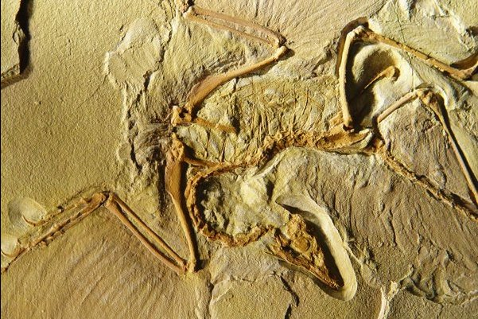

As you know, Dr. Alan Feduccia (evolutionary biologist and chair of the Biology Dept at University of North Carolina, Chapel Hill) spoke at the San Diego Natural History Museum on the origin of birds November of 2004. During that talk he said, "Paleontologists have tried to turn Archaeopteryx into an earth-bound, feathered dinosaur. But it's not. It is a bird, a perching bird. And no amount of 'paleobabble' is going to change that." (Link)

During this talk he especially emphasized the following points:

• Archaeopteryx is a true bird.
• "Dinofuzz" is nothing more than collagenic fibers found on many other fossils.
• Today's highly touted "Feathered Dinosaurs" are a myth: some fossils (i.e. Caudipteryx) have flight-feathers but they aren't really dinos--they are secondarily flightless birds
• Birds have digits 2-3-4, and theropods have digits 1-2-3. This is powerful evidence that birds couldn't have evolved from theropod dinos.
• Also, the theropod --> bird hypothesis requires that birds evolved flight from the ground-up. If Caudipteryx has feathers but not for flight, Feduccia finds this explanation quite tenuous. Put simply, ground-up proponents say feathers were pre-adapted for flight but evolved originally for insulation. This is silly because feathers are perfectly suited for flight, and very energetically costly to produce. If insulation was all that was needed, hair would have done the job just fine and would NOT have been nearly so costly. It strains credibility to say feathers evolved for insulation.
• Feduccia prefers Microraptor as an ancestor of birds because he likes the trees-down hypothesis, not the ground-up hypothesis.
• If birds didn't come from theropods, this does leave a rather large time-gap where there is essentially no fossil documentation of exactly what sort of dinos or other reptiles from which birds would have evolved.
(2) Sinornithosaurus, a dromeosaur dinosaur similar to Archaeopteryx, has
long, filamentous integument, probably feathers.

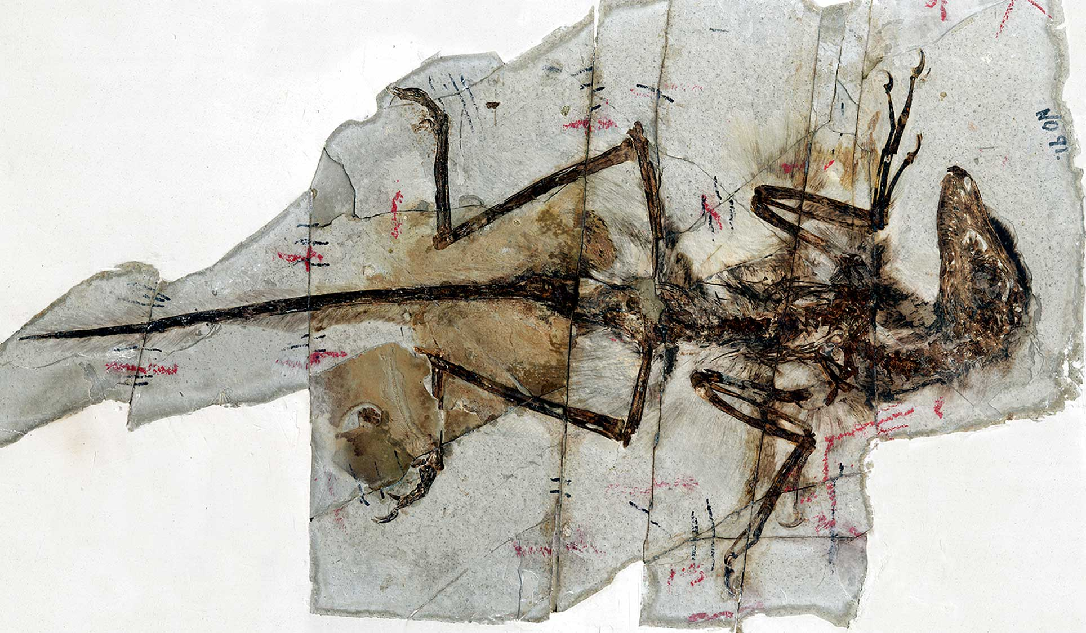

Dromeosaurs are "raptors". Because of the arguments listed above, those like Feduccia argue that "the microraptors of China are birds, regardless of their ancestry."

Feduccia, A., Lingham-Soliar, T. & Hinchliffe, J.R. J Morphol 266 , 125-66 (2005).

(3) Sinosauropteryx has long fibers on it dorsally.

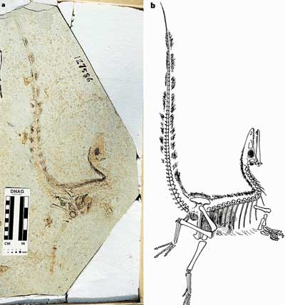

Speaking specifically of Sinosauropteryx Theagarten Lingham-Soliar of the University of KwaZulu-Natal noted that the patterns are the remains of "structural fibers, probably collagen—the most abundant fiber in vertebrates—of the skin and the dorsal frill."

The findings were published in the journal Proceedings of the Royal Society B.

(4) Collagen fibers from an outer covering are only unambiguously known from
fossils through electron miscrscopy (as far I know).

Seems like a minor point when it comes to supporting the hypothesis of true feathers.

(5) Shuvuuia is known from hairlike integument; Shuvuuia is considered a bird
(all unambiguous birds have contour feathers covering them).

Shuvuuia has long tubular filaments that are also beta-keratin positive (and lack alpha-keratin). Such filaments that are both morphologically tubular and immunologically bird-like, have not been demonstrated in true dinosaurs. I fail to see how the demonstration of feathers in a "bird" like Shuvuuia is helpful in supporting the notion of feathered dinosaurs?

(6) Similar structures (preserved in two-dimensions) are known from:
Sinocalliopteryx, Bipeiosaurus, Dilong (non-maniraptoran theropod),
Pedopenna, etc.

The argument that these structures are "similar" seems to be debatable - based on low-resolution gross appearance without the support of tubular morphologic or immunologic beta-keratin demonstration.

(7) The reason these structures are not preserved 3-dimensionally, other than
in Shuvuuia, is because the sediment compressed not only the filament
structures, but the whole skeleton, flat. This does not mean that the
filaments were not "tubular".

And, it doesn't mean that they were either. The lack of evidence isn't the same thing as positive evidence. Beyond this, it is much easier to compress or "flatten" a larger tubular structure, like a bone, relative to a tubular structure with a much small cross diameter - like a filament.

(8)Maniraptorans are considered by first considered to be neoflightless birds
by G.S. Paul (2002) who considers birds to be dinosaurs.

And maniraptorans are considered by a minority of scientists to be true birds, not dinosaurs.

(9) A similar line of thought is held by L. Martin, A. Feduccia, S. Olson, S.
Czerkas, and G. Olshevsky; except the first four hold that maniraptorans are
not dinosaurs, and the similarities are due to convergence. The latter
believes that all dinosaurs are neoflightless birds.

So, there seems to be a difference of opinion are far as what the various similarities and differences mean. Certainly this is true regarding the dinosaur feature hypothesis.

(10) Protein testing on soft tissue preserved in T. Rex bone marrow indicates
a close relationship with chicken protein, sealing the evidence.

Just like human and ape DNA and proteins are quite similar. Did you know that the human genome is only about 500 genes different from the rat genome?

Again, the really important question isn't in regard to such similarities, but in regard to the functional genetic differences that make living things that all share many interesting features uniquely different with regard to functionality.

(11) Biochemical testing on Shuvuuia's filaments show analogous to the
proteins in bird feathers. It is more birdlike in all skeletal attributes
(skull, pelvis, arm, thorax, etc.) than Caudipteryx (which has contour
feathers, and its pelvis is more similar to regualr theropds), and yet does
not have contour feathers, but filaments of similar length and shape to
Sinosauropteryx. (Why is this?)

Again, the argument of similarities with regard to filaments is based on very general features. The "shape" argument is not supported. Even by your own admission the tubular features of Shuvuuia's filaments are not seen in Sinosauropteryx or any other fossil that is unambiguously agreed to be a "dinosaur" rather than a true "bird".

(12) Tubular filaments are found on Psittacosaurus, a non-theropod,
ornithiscian dinosaur. Filaments are larger than Shuvuuia's, but structurally
similar.

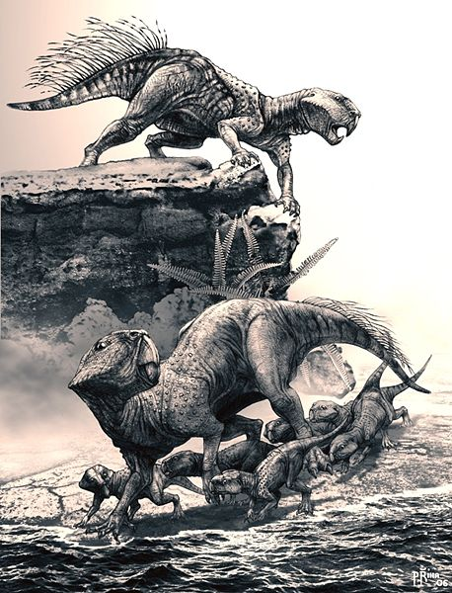

Porcupines also have hollow bristles that are not remotely "feather like". The same thing goes for the linearly arranged bristles on the tails of Psittacosaurus. You are really reaching for straws here it seems - pun intended ; )

"[a]t present, there is no convincing evidence which shows these structures to be homologous to the structurally different [feathers and protofeathers] of theropod dinosaurs."

Mayr, Gerald, Peters, D. Stephan, Plodowski, Gerhard & Vogel, Olaf. (2002). Bristle-like integumentary structures at the tail of the horned dinosaur Psittacosaurus. Naturwissenschaften 89: 361–365.

(13) Dilong's splay of feathers 3/4 inches long on its tail show strong
evidence of feathers on a non-maniraptoran theropod.

Where is the evidence of tubular structure combined with beta-keratin expression (and lack of alpha-keratin)? Again, having filamentous fibers surrounding a fossil is not the same thing as demonstrating positive evidence for real feathers or even feather-like structures.

(14)Turner and colleagues, in 2007,

reanalyzed the anatomical features of
Dilong and found that it was not a tyrannosaur. They placed Dilong two steps
above the tyrannosaurs in their phylogeny; more advanced than Coelurus, but
more primitive than the Compsognathidae. Meaning it is more basal
("primitive") than Sinosauropteryx (which is a compsognathid).

Relevance? Both have the same lack of convincing positive evidence for feathers or even proto-feathers.

(15) Features that are found in dinosaurs, but not in classical birds are
found in all maniraptorans, including (but not limited to) an antorbital
fenestra. So, are maniraptorans birds, or not?

According to Feduccia, that depends upon which digits of the hand are preserved from embryonic development (see above).

This above indicates that dinosaurs and birds ARE related. No single piece of
evidence indicates this, rather it is each piece of evidence taken together
that points to this: the morphological, biochemical, and integumentary, as
well as the logical conclusion derived from them, put together.

No one is arguing that there are many significant similarities between birds and dinosaurs. What is being argued here strictly concerns the notion that creatures unambiguously considered to be "dinosaurs" having real "feathers" or "protofeathers". I don't see the evidence as conclusively pointing in this direction regarding this particular feature. Other similarities are quite clear. Feathers don't seem to be one of these.

You wrote: "My point then is not so much to question similarities, but to
show that scientists are often guided more by their pre-conceived notions in
their interpretations of these similarities than by true science that is
built upon predictive value of hypotheses with the potential for
falsification. There is simply a great deal of bias in science - as there is
in all human endeavors. That is why a bit of personal investigation and
consideration of the evidence is needed before this or that "story" is
accepted as "truth"."
Me: Your point, excuse me for being blunt, does more harm than good: (1) it
tarnishes your very well put-together website, (2) is much too skeptical
("morphology is not important"--in effect",

I never said that morphology is not important. It is important. Sometimes it is all there is. However, one should be careful when it comes to using morphologic similarities to jump to evolutionary conclusions - conclusions which have been wrong, painfully wrong, over and over again when they seem to fit preconceived notions. Bias is a powerful force with which we all must deal.

(3) is a dogmatic, an a priori
argument worse than that of the dinosaur theorists,

You misrepresent me.

and (4) assumes way to many "coincidences" .

How is that? I've already told you, several times, that I recognize the many shared similarities between birds and dinosaurs. You are just upset that I don't recognize the one feature that you seem to find especially important (i.e., feathers) as a shared similarity. Sorry . . .

If you want to make that point, without forsaking
truth, you should quote the (many) evolutionists who often say that
cladistics and phylogenetics based on morphology can be, and often are,
misleading.

I have done this in many of my essays. This is one of my main points which I often support by quoting evolutionists and mainstream scientists in general. To give weight to such points, why would I reference anyone from my own perspective?

Alternatively, even better yet, show how the preconceived
notions of anti-dinosaur-origin theorists do the same of having a "great deal
of bias in science."

Everyone is biased - all all sides of every issue. That is why it is important to individual consider the evidence.
By not showing both sides of this, it damages
credibility to your otherwise sound scientific observations. This last point
was the main reason for contacting you regarding this topic of feathered
dinosaurs.

The article I reference briefly outlines both sides of this particular issue. The fact that I didn't go into great detail regarding this side issue is due to the fact that I consider it a side issue. However, I have now added this exchange to the article. Perhaps this is the balance that you are looking for?

Anti-dinosaur-origin theorists are as much, if not more so, guided by
preconceived notions (that only birds can have feathers and that no matter
how skeletally or genetically similar an organism is to another group,
because it has feathers it MUST be a bird). THAT is poor science TOO.

It is certainly a bias, but it is not, by itself, poor science.

First,
they say that morphology isn't important, or misleading, yet because certain
maniraptorans have feathers they say they are birds, and, oh my! they have
similar skeletal features (but those don't count, of course), so they must be
birds by virtue of their morphology. Something doesn't follow. There is a
paradox and downright contradiction here. If morphology doesn't count, what
is a bird (oh, it has feathers! right, then what about all the birds that are
not found with feathers? they must not be birds)? (there may be a hint of
sarcasm detected above)

It seems to me that you are doing the same thing. What is your definition of a "bird" vs. a "dinosaur"? Are you free of all bias when you decide on what these definitions should be?

That is why, if you must keep that essay on what SOME think to be the dubious
nature of feathered dinosaurs, then to be balanced and fair, I think you
should have another more fair view of this debate. In the end though I must
urge you to at the very least write a new essay that is much more objective.
In fact, if your main point is that modern classification schemes (including
phylogenetics and cladistics), I would urge you to talk about that
exclusively instead of the dinosaur-bird debate, this would do much more
service to your site.

I do talk about phylogenetics on my website. I have an entire essay devoted to this topic. (see Link). The dino-feather controversy simply helps to illustrate the nature of bias and how different scientists, even mainstream scientists who all believe in evolution, can look at the very same data and come away with very different interpretations of that data.

It seems, in the end, what was intended by me to be something helpful on the
relationships of birds to dinosaurs, etc., has turned out to be a complete
and utter failure; with you rejecting basically everything I have said by
saying that one cannot determine relationships by morphology.

What I said is that one can be easily confused in one's interpretation of morphologic similarities. Also, what do you mean by "relationships". There is a big difference between the term "similarities" and "relationships" you know. The later indicates some sort of common decent - generally speaking. Again, similarities can be explained by either common decent or common design. Determining which of these two possibilities is most likely boils down to the differences, not the similarities.

This is a
dogmatic approach that is most unscientific and and unhelpful. In the end one
cannot be certain about anything beyond an unreasonable doubt. You could
doubt everything because you could say that we can never really know what
does exist. Everything could be a dream or an illusion. This type of thought
process is highly philosophical, and highly non-beneficial to science and, in
practical terms, it is worthless.

Again, you misinterpret me.

I really regret if I have offended you, but to deny the obvious to make a
point is highly deconstructive to any point you try to make.

I'm not the only one who doesn't see certain interpretations of "dino-fuzz" as being as "obvious" as you do.

Furthermore, morphology may be more reliable in determining relationships
than you may think. Granted, as of yet we cannot rely on them to stand as a
firm basis for species and genera, and possibly even families, yet we do see
general relationships that at broader orders of classification we can be
fairly firm with. Just because morphology has proved unhelpful in the more
specific classifications does not mean it is misleading in broader
classifications (such as superfamilies, orders, superorders, subclasses,
classes, etc.) which we are dealing with here.

Classification schemes based on physical feathers or even genetic features are simply our own human way to make sense of things. We humans just like to group things together - to "classify" them. Such classifications schemes may or may not say anything about their actual origin aside from there being a likely commonality regarding whatever origin was actually responsible. Again, determining the likely origin I think is found in looking more at the differences than at the similarities.

If you are not too offended after this email, I will discuss evolution in
general in another email later, because I feel it is too important to
keep serving as an endnote to these discussions.

Great . . .

Hopefully, though, if necessary, we can disagree to disagree amicably.

You mean agree to disagree? ; )

Thanks for listening to this infernal, tangential, and a "whole lot of other
adjectives" rant,
Again, thanks a lot,

Same to you . . .

Zach A.

Sean

